DATE | 29 January 2018
PLACE | MOE HQ (1 North Buona Vista Drive)
PROJECT | MOE SLS Mathematics (Rate and Speed) Interactive Project
ATTENDEES | MOE:  - Melvin Chin  - Chuyan Tan  FILM MAGIK:  - Damien Krishnan  - John Nepomuceno
Rafi: Items in Yellow
Vince: Items in Green
Items concerning both gentlemen will be repeated and highlighted accordingly.
CONTACT REPORT | - FEEDBACK FROM PROTOTYPE PRESENTATION TO TEACHERS:  - DESIGN ELEMENTS:  - Overall futuristic design for the graphical user interface (GUI) was received positively.  - The town background also got positive feedback.  - Sid’s image was received well.  - Scrap top view plan and replace with a “side profile.” After three seconds of moving, the simulation layouts turn into the side profiles with the design elements turning into numbered colored dots moving along a calibrated path.  - Scrap top view plan and replace with a “side profile.” After three seconds of moving, the simulation layouts turn into the side profiles with the design elements turning into numbered colored dots moving along a calibrated path.  - Add more details to the cars.  - Add numbers to the design elements. Use Herbie as reference:  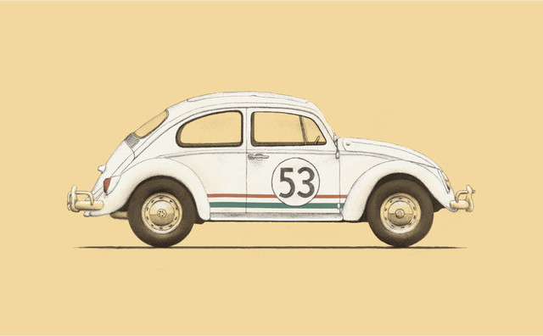  - Properly label/identify towns as Town 1 so on. With this, design elements may be put on their proper points of origin.  - Add numbers on top of the design elements (car, bus, PEV, etc) especially if they turn into moving colored dots on the side profiles. The numbers and the dots then become merged elements.  - Add numbers on top of the design elements (car, bus, PEV, etc) especially if they turn into moving colored dots on the side profiles. The numbers and the dots then become merged elements.  - OTHER GUI CONCERNS:  - Screen layout for the homepage may tend to reconfigure especially if projectors used are older models/versions. The 16:9 layout becomes 4:3 and converts from landscape to portrait. Film Magik to look into and troubleshoot this matter.  - To address the concern cited in #1, while MOE prepares to fully replace the schools’ projectors with more modern ones, Chuyan Tan suggested that the home page sequence be changed from:  - Indirect Proportion 4 Circular Journey  - Moving in Opposite Directions 5 Travel Graphs  - Moving in the Same Direction 6 Exploration Mode  to:  - Film Magik to double check on standardizing the “look” of the pages. When accessing through internet explorer, font type used in tabs and titles change to Times New Roman.  - SPECIFIC SIMULATION CONCERNS:  - Indirect Proportion Example 1 (Robot Mural Artists):  - As Sid talks, important information and keywords should come in as supplementing visuals.  - No need to include subtitles of Sid’s lines for the hearing impaired.  - As Sid talks, important information and keywords should come in as supplementing visuals.  - Indirect Proportion Example 2 (Pool):  - Replace pool with a fish tank (aquarium) being filled by 6 taps.  - Indirect Proportion Create-your-Own (Monkeys and Bananas):  - The correct answer, “5” does not come out.  - Replace the preset number choices with empty boxes. Set  number selections from 1-300.  - Moving in the Same Direction (Simulations 1 and 2):  - Change “PEV” to “Rider.”  - Change “PEV” to “Rider.”  - Circular Journey:  - Design elements should move on the same orbit not on two separate tracks.  - Replace “water” with “land” and replace boats with motorbikes, to be identified as Riders 1 and 2.  - Replace “water” with “land” and replace boats with motorbikes, to be identified as Riders 1 and  - Meeting points must have flags to mark the said spots.  - Meeting points must have flags to mark the said spots  - Travel Graphs:  - Have only one simulation. The drop down selection will do the changing to any of the three graphs.  - Increasing speed stops at 2 hours. Correct this to 24 hours.  - Change the preset time for all three graphs to 24 hours.  - Check bugging issues.  - Exploration Mode:  - Raise tabs for Opposite Direction and Same Direction instead of setting these along the other buttons.  - GENERAL CORRECTIONS FOR THE SIMULATIONS:  - Design elements’ behavior/action onscreen (going to end of screen) must not affect the formula. The “Distance between” should not go to zero when objects reach the edge of the screen and stop.  - Melvin Chin reminded Film Magik that the buttons/tabs should light up when pressed. Film Magik advised Melvin Chin that this is currently being worked on.  - Chuyan Tan will be updating the formula for simulations with “time delay.” Two formulas will have to be used to arrive at the correct answers.  - Similarly, additional revisions and updates will be plugged in by Miss Tan in the provided updated wireframe. The said modifications, however, are not expected to be incorporated in the draft that needs to be presented on 05 February (Monday).  - Include a dropdown for “jump to meeting point” for all simulations, except for indirect proportion.  - For answers that need to be keyed in, supply blank boxes.  - When objects meet, there should be an indication of the meeting (short of a celebration). Use audio or artwork of revelry, fireworks or similar elements.  7a. When objects meet, there should be an indication of the meeting (short of a celebration). Use audio or artwork of revelry, fireworks or similar elements.  - The meeting point needs to be marked by a flag to permanently see/indicate where this happened.  8a. The meeting point needs to be marked by a flag to permanently see/indicate where this happened.  - Final answers may be in two decimal places, even if the inputs are whole numbers.  - All “time/clock counters” should be editable. All “distance between…” should not be editable. A “result” button should be next to the “distance between” window.  - Allow numerical input for the “time/clock counters” to be in two decimal places. Allow only whole numbers for “distance between.”  - SID’S APPEARANCE:  - Minimize Sid’s appearances. For example in CYOs, Sid’s face may just pop up to introduce the task. Don’t make Sid’s image dwell.  1a. Minimize Sid’s appearances. For example in CYOs, Sid’s face may just pop up to introduce the task. Don’t make Sid’s image dwell.  - Delete introduction page for Sid. Sid will pop in spontaneously.
  - Indirect Proportion 2 Moving in Opposite Directions
  3 Moving in the Same Direction 4 Circular Journey
  - Travel Graphs 6 Exploration Mode
NEXT STEPS | - Next meeting is on 05 February (Monday) at 9am. Draft needs to be submitted via FTP, google drive, and dropbox on Saturday, 03 February (Saturday) for MOE’s critique, prior to the 05 February meeting.
NEXT STEPS | - Next meeting is on 05 February (Monday) at 9am. Draft needs to be submitted via FTP, google drive, and dropbox on Saturday, 03 February (Saturday) for MOE’s critique, prior to the 05 February meeting.

